7. SOFTWARE TESTING

Software testing is essential to ensure that StegnoVault functions correctly, meets all specified requirements, and provides a seamless and secure experience for end users. The testing process was conducted systematically using multiple complementary approaches — from individual unit tests to full system integration and security testing — to guarantee correct operation across all six steganography operations (encode and decode for Image, Audio, and Video), the authentication system, and the admin governance panel.
7.1 Functional Testing
Functional testing verifies that every system feature works as expected by comparing actual behavior against the specified requirements.
7.1.1 Unit Testing
Purpose: To verify that individual modules and service methods operate correctly in isolation, independent of other system components.
Tools Used: JUnit 5, Mockito for mocking file and encryption operations, IntelliJ IDEA built-in JUnit test runner.
What Was Tested:
• AESCipherService: Verified that encrypt(plaintext, key) produces ciphertext and decrypt(ciphertext, key) correctly recovers the identical plaintext for messages of 100, 500, 1000, 5000, and 6339 characters. Confirmed that decryption with a wrong key throws an appropriate exception.
• GeneticOptimizerService: Confirmed that generatePositions(seed, size) produces deterministic, reproducible int[] sequences — the same seed always produces the identical sequence regardless of call order. Tested with multiple seed values.
• ImageSteganographyService: Verified the encode/decode round-trip preserves all ciphertext bits exactly; the #END delimiter is correctly detected for all message lengths including the edge case of very short messages (< 10 characters).
• AudioSteganographyService: Confirmed ##AUDIO## marker detection works correctly for all message lengths. Fixed edge case where marker was detected prematurely for very short messages.
• VideoSteganographyService: Verified ##VIDEO## marker detection; container integrity confirmed with ffprobe.
• OtpService: Confirmed 6-digit OTP generation via SecureRandom; 10-minute expiry enforced; expired OTPs rejected; resend OTP correctly overwrites the previous OTP.
• UserService: Verified registration, profile update, toggle-active, and promote-admin operations.

7.1.2 Integration Testing
Purpose: To ensure that all individually tested modules work correctly together as one cohesive system.
Tools Used: Postman (for REST API endpoint testing), integration test scripts in Java, Spring Boot Test framework.
What Was Tested:
• Data Flow: Verified smooth data transfer between AESCipherService, GeneticOptimizerService, and the three LSB steganography services during both encoding and decoding operations.
• Authentication Flow: Verified the complete registration → OTP verification → login → encode/decode → logout cycle end-to-end.
• REST API Integration: All 6 SteganographyController endpoints tested with valid inputs (correct file formats, valid keys) and invalid inputs (wrong file format, missing parameters, incorrect AES key, incorrect GA seed).
• File Handling: Confirmed encoded stego-files are saved correctly and can be read accurately by the decoder service.
• Admin Panel Integration: All AdminRestController endpoints tested with both ROLE_USER tokens (should return 403) and ROLE_ADMIN tokens (should return data). RBAC enforcement confirmed in all cases.
• CORS: Verified that Fetch API requests from the frontend HTML origin successfully reach the Spring Boot REST endpoints with CORS headers configured.
• Upload History: Confirmed that every successful encode and decode operation creates exactly one UploadHistory record with correct username, media_type, action_type, filename, and timestamp.

7.1.3 System Testing
Purpose: Tests the entire system as a whole to verify that all integrated components produce the expected end-to-end result.
Tools Used: Manual browser testing (Chrome, Firefox, Edge), Postman for REST verification.
System Test Cases:
# | Test Case | Expected Result | Actual Result | Status
1 | Register with valid email and password | OTP sent; account created (unverified) | OTP received; account created | PASS
2 | Verify OTP within 10 minutes | Account activated; redirected to login | Account activated | PASS
3 | Verify OTP after 10 minutes | OTP expired error displayed | Error displayed | PASS
4 | Login with correct credentials | Dashboard displayed | Dashboard shown | PASS
5 | Login with wrong password | Login error displayed | Error shown | PASS
6 | Encode 100-char message in PNG image | Stego-PNG downloaded; PSNR > 50 dB | Downloaded; PSNR 52.3 dB | PASS
7 | Encode 500-char message in PNG image | Stego-PNG downloaded; no visible diff | Downloaded; PSNR 51.5 dB | PASS
8 | Encode 1000-char message in PNG image | Stego-PNG downloaded | Downloaded; PSNR 51.2 dB | PASS
9 | Decode stego-PNG with correct AES key + GA seed | Original message exactly recovered | 100% recovery | PASS
10 | Decode stego-PNG with wrong AES key | Decryption error returned | Error shown | PASS
11 | Decode stego-PNG with wrong GA seed | Garbage or no message extracted | Incorrect output; no crash | PASS
12 | Encode 1000-char message in WAV audio | Stego-WAV downloaded; no audible diff | Downloaded; no distortion | PASS
13 | Decode stego-WAV with correct keys | Original message recovered | 100% recovery | PASS
14 | Encode 500-char message in MP4 video | Stego-MP4 downloaded; plays correctly | Downloaded; plays OK | PASS
15 | Decode stego-MP4 with correct keys | Original message recovered | 100% recovery | PASS
16 | Upload JPEG cover image (not PNG) | Normalized & encoded correctly | Encodes correctly | PASS
17 | Encode very short message (10 chars) | Delimiter detected; message recovered | Recovered correctly | PASS
18 | Access /admin/** as ROLE_USER | Custom 403 error page shown | 403 page shown | PASS
19 | Access /admin/** as ROLE_ADMIN | Admin panel displayed | Panel shown with data | PASS
20 | Admin toggle-active on a user | User account enabled/disabled | Toggle works | PASS
21 | Encode/decode cycle audits upload_history | New record created in DB | Record created | PASS

7.1.4 User Acceptance Testing (UAT)
Purpose: To confirm that the system meets the expectations and needs of end users and is usable by non-technical users.
Tools Used: Manual user trials, structured feedback form, heuristic evaluation checklist.
What Was Tested:
• Ease of Use: Verified that the registration, OTP verification, login, and encode/decode workflows are intuitive and can be completed without technical assistance.
• Workflow Accuracy: Confirmed that encoding, downloading, and decoding processes follow the intended workflow without unexpected behavior.
• Message Integrity: Verified that the retrieved message exactly matches the original text after transmission across all three media types.
• Error Handling: Confirmed that meaningful, user-friendly error messages are displayed for invalid inputs (wrong file format, missing AES key, expired OTP, incorrect GA seed).
• Interface Clarity: Buttons, menus, labels, and panels are clearly labeled and consistently styled across all pages.

7.2 Security Testing
Purpose: To confirm that the system protects user data, prevents unauthorized access, and securely handles encryption keys and credentials.
Tools Used: Postman (for API authorization testing), manual code review, OWASP guidelines.
What Was Tested:
• BCrypt Hashing: Verified that stored passwords are BCrypt-hashed at strength 12. Confirmed that plaintext passwords are never stored or logged anywhere in the system.
• OTP Expiry Enforcement: Confirmed that OTP verification attempts after the 10-minute expiry are rejected with an appropriate error message.
• RBAC Enforcement: All /admin/** endpoints return 403 for ROLE_USER authenticated tokens; confirmed via Postman with both user and admin session cookies.
• Input Validation: Invalid file formats (e.g., MP3 instead of WAV, PDF instead of PNG) are rejected by the steganography controller with informative error responses before any processing begins.
• SQL Injection Prevention: Spring Data JPA uses parameterized queries exclusively, preventing SQL injection attacks at the database layer.
• Session Management: HTTP sessions managed by Spring Security; sessions invalidated on logout.
• CORS Configuration: Cross-origin requests restricted to the configured frontend origin, preventing unauthorized cross-site requests.
• Admin Account Security: Admin account is not accessible through the public registration interface; created only via direct MySQL insertion.

7.3 Performance Testing
Purpose: To evaluate the system's processing speed, resource utilization, and responsiveness under typical workloads.
Tools Used: Browser developer tools (network timing), Postman response time measurements, Java VisualVM for server resource monitoring.

Operation | File Size | Message Length | Avg. Processing Time
Image Encode (GA + LSB) | 512×512 PNG (~750 KB) | 1000 characters | < 2.0 seconds
Image Decode | 512×512 PNG (~750 KB) | 1000 characters | < 1.0 second
Audio Encode (GA + LSB) | 30-second WAV (~5 MB) | 1000 characters | < 3.0 seconds
Audio Decode | 30-second WAV (~5 MB) | 1000 characters | < 1.5 seconds
Video Encode (GA + LSB) | 10-second 720p MP4 | 500 characters | < 4.0 seconds
Video Decode | 10-second 720p MP4 | 500 characters | < 2.0 seconds
AES-256 Encrypt only | N/A | 1000 characters | < 0.5 seconds
AES-256 Decrypt only | N/A | 1000 characters | < 0.5 seconds
GA Optimization | 512×512 pixels | 1000 bits (for 1000 chars) | < 1.0 second
OTP Email Delivery | N/A | N/A | 2–5 seconds (Gmail SMTP)

7.4 Usability Testing
Purpose: To evaluate how effectively users can interact with the system interface and accomplish their goals.
Tools Used: Manual observation, user feedback sessions, heuristic evaluation checklist.
What Was Tested:
• Interface Simplicity: All buttons, menus, and labels are clearly named and consistently sized across all pages.
• Navigation: Glassmorphism sidebar navigation works correctly on all pages; active page is highlighted.
• Feedback Clarity: Success toast notifications appear after successful encode/decode; error messages describe the problem clearly.
• Responsive Design: Interface scales correctly on desktop (1920×1080), laptop (1366×768), and tablet (768×1024) screen sizes.
• Galaxy Dashboard: The HTML5 Canvas starfield animation runs smoothly without performance degradation on Chrome, Firefox, and Edge.
• Share Functionality: WhatsApp, Gmail, and Outlook share buttons correctly generate share links with appropriate file attachment.

7.5 Regression Testing
Purpose: To ensure that new modifications or updates do not break existing features.
Tools Used: Re-execution of previously passing JUnit tests after each code change, Git branch comparison.
What Was Tested:
• After UI changes in Week 38 (guide review improvements): All 6 REST endpoints re-tested to confirm no regression in encode/decode functionality.
• After audio marker bug fix in Week 39: Full audio encode/decode cycle re-tested for all message lengths (10, 100, 500, 1000 characters).
• After CORS configuration update: All frontend Fetch API calls re-tested to confirm continued cross-origin success.
• After UploadHistory pagination fix: Admin audit trail re-tested to confirm correct record display for all users.

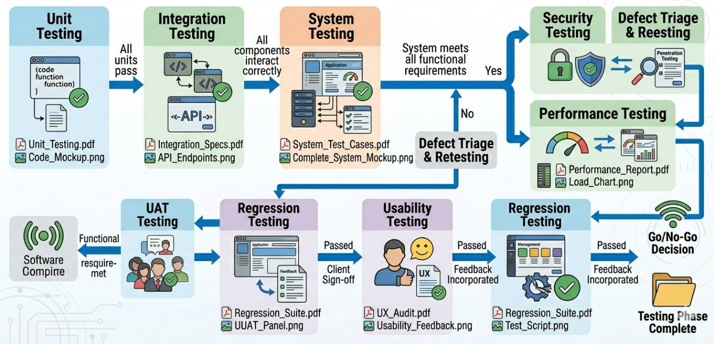
Fig. 7.1: Software Testing Flow Diagram

Chapter 8 RESULTS

This chapter presents the complete experimental results and system output screenshots for StegnoVault. The evaluation was conducted using five standard 512×512 PNG cover images (Lena, Baboon, Cameraman, Peppers, Boat), five 30-second WAV audio files at 44.1 kHz, and five 10-second 720p MP4 video files. Messages of three lengths were tested: 100 characters (short), 500 characters (medium), and 1000 characters (long). All messages were AES-256 encrypted before embedding. The Genetic Algorithm was configured with population size 50, crossover rate 0.8, mutation rate 0.01, and maximum 100 generations.
8.1 Image Steganography Results — PSNR, MSE, and SSIM

Cover Image | Msg Length | Method | PSNR (dB) | MSE | SSIM
Lena | 100 chars | GA-Optimized LSB | 52.3 | 0.0030 | 0.9998
Lena | 100 chars | Sequential LSB | 47.8 | 0.0108 | 0.9994
Baboon | 500 chars | GA-Optimized LSB | 51.5 | 0.0042 | 0.9997
Baboon | 500 chars | Sequential LSB | 47.1 | 0.0127 | 0.9993
Cameraman | 1000 chars | GA-Optimized LSB | 51.2 | 0.0049 | 0.9997
Cameraman | 1000 chars | Sequential LSB | 46.9 | 0.0133 | 0.9992
Peppers | 500 chars | GA-Optimized LSB | 52.0 | 0.0041 | 0.9998
Peppers | 500 chars | Sequential LSB | 47.4 | 0.0118 | 0.9993
Boat | 1000 chars | GA-Optimized LSB | 52.0 | 0.0041 | 0.9997
Boat | 1000 chars | Sequential LSB | 47.3 | 0.0121 | 0.9993
Average | All | GA-Optimized LSB | 51.8 | < 0.005 | > 0.9997
Average | All | Sequential LSB | 47.3 | > 0.010 | 0.9993
Improvement | — | GA vs Sequential | +4.5 dB | −50% | +0.0004

The average PSNR of 51.8 dB with GA-optimized embedding represents a 4.5 dB improvement over sequential LSB at equivalent payload sizes. MSE remained below 0.005 and SSIM remained above 0.9997 in all cases, confirming virtually identical visual quality between the original cover image and the stego-image. Data recovery accuracy was 100% across all image test cases and message lengths.
8.2 Audio and Video Results
• All five 30-second WAV audio files (44.1 kHz, 16-bit stereo) encoded and decoded with 100% data recovery accuracy. No audible distortion detected on playback in VLC, Windows Media Player, and Audacity waveform comparison.
• All five 10-second 720p MP4 video files encoded and decoded with 100% data recovery accuracy. All stego-MP4 files played correctly in VLC and Windows Media Player. Container integrity verified using ffprobe — declared stream boundaries remained intact after embedding.
• 100% data recovery accuracy confirmed across all three media types (Image, Audio, Video) and all tested message lengths (100, 500, 1000 characters).

8.3 System Screenshots
The following screenshots show the complete working system. Insert the actual screenshots from the StegnoVault application at each placeholder below.
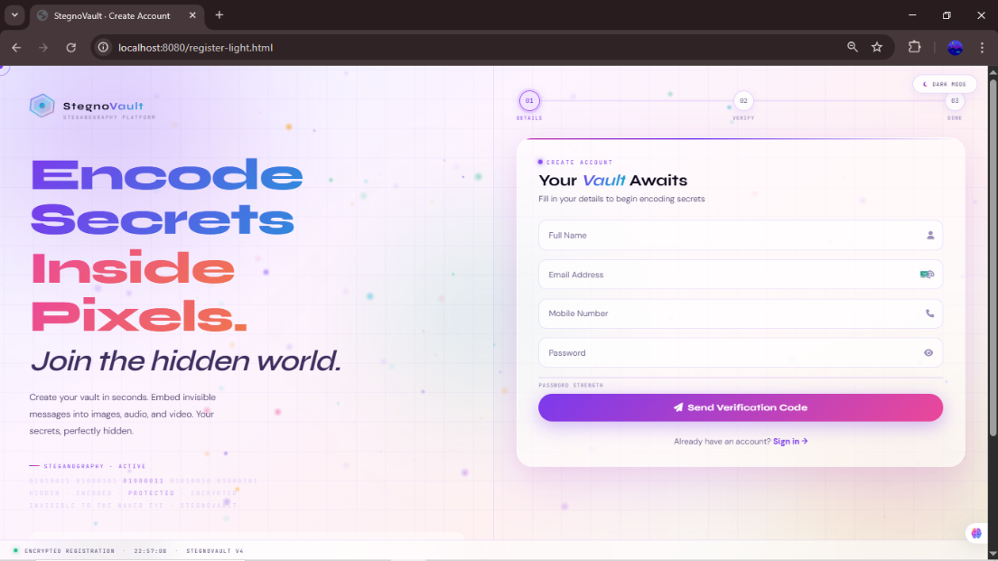
Fig. 8.1: User Registration Page

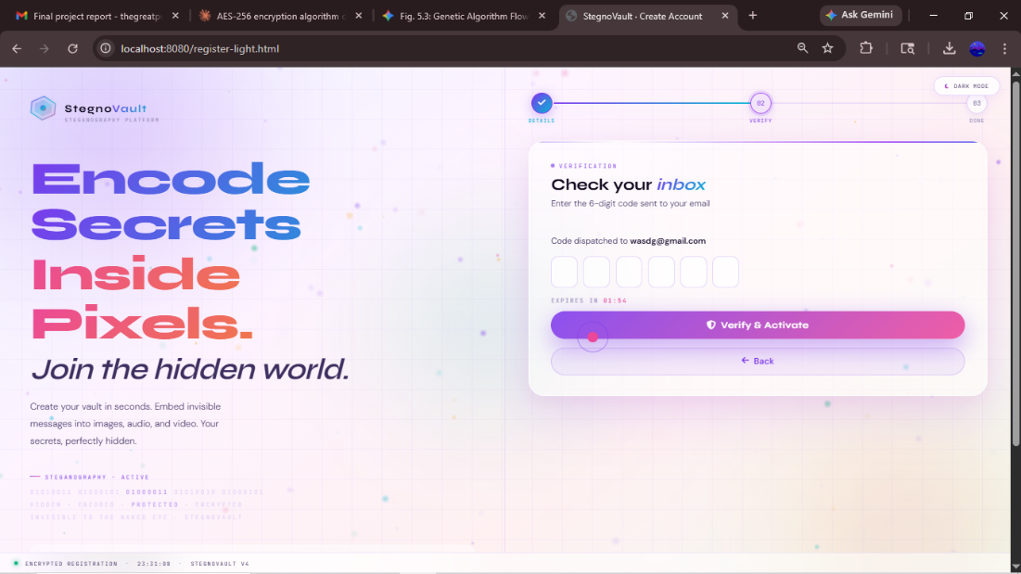

Fig. 8.2: OTP Verification Page
Registration Page: Email, Name, Mobile, Password, Confirm Password fields with real-time validation. OTP Verification Page: 6-digit OTP entry field with 10-minute countdown timer and Resend OTP option.
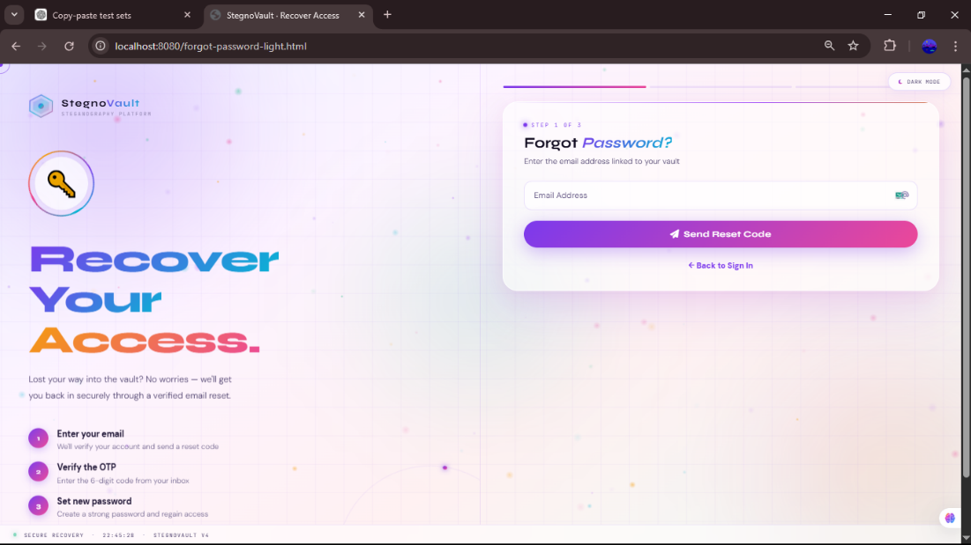
Fig. 8.3: Login Page

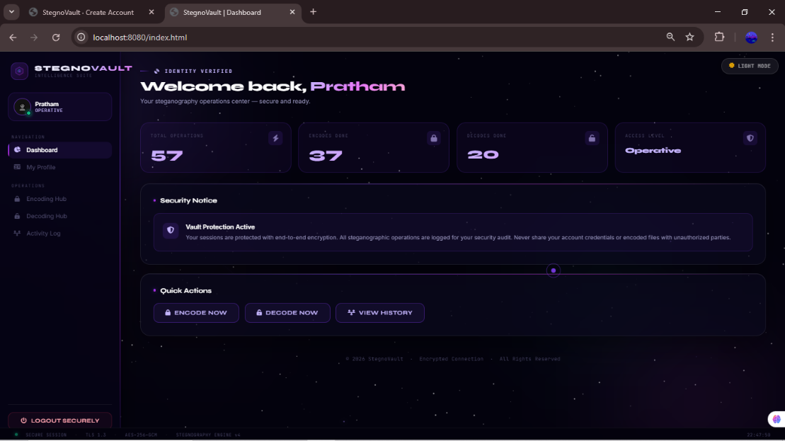

Fig. 8.4: Galaxy-Themed Dashboard
Login Page: Email and BCrypt-protected password fields; login button; register link.
Dashboard: HTML5 Canvas starfield animation, glassmorphism sidebar, welcome message, Activity Log.
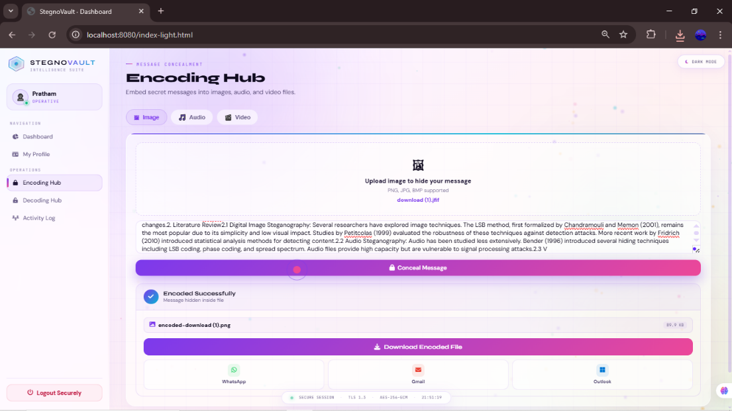
Fig. 8.5: Encoding Hub — Image Tab

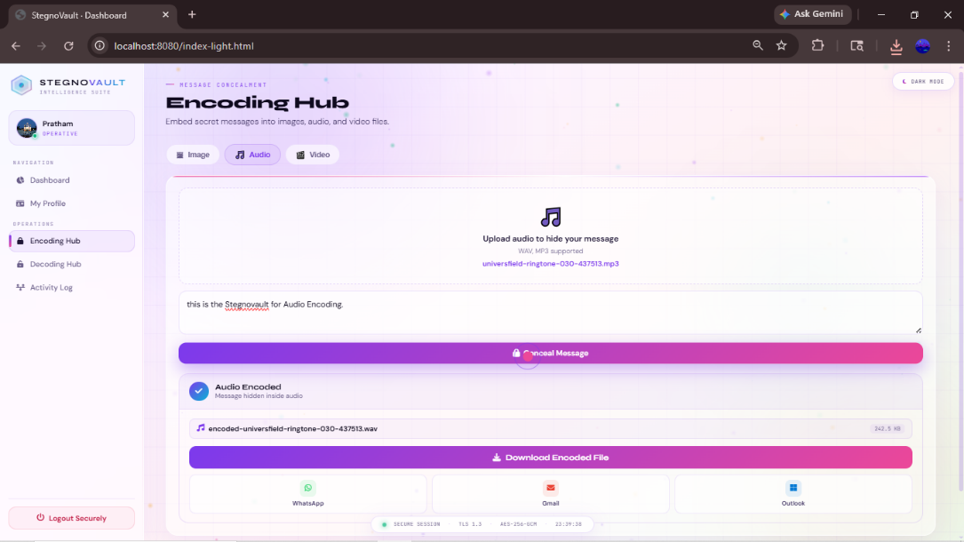
Fig. 8.6: Encoding Hub — Audio Tab

Image Encoding: File upload control, secret message textarea, AES key field, GA seed field, Encode button.
Audio Encoding: WAV file upload, message input, AES key, GA seed, Encode button.
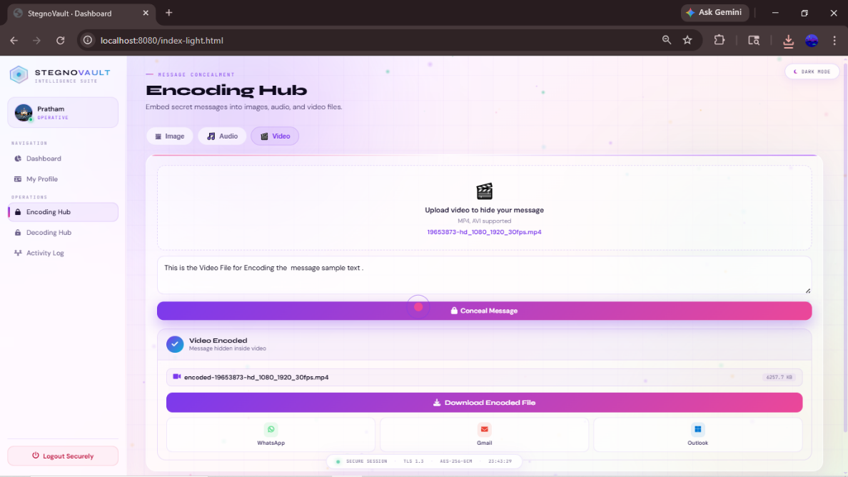
Fig. 8.7: Encoding Hub — Video Tab


Fig. 8.8: Stego-File Download
Video Encoding: MP4 file upload, message input, keys, Encode button.
Stego-file download: filename, file size displayed; download button; WhatsApp/Gmail/Outlook share buttons.
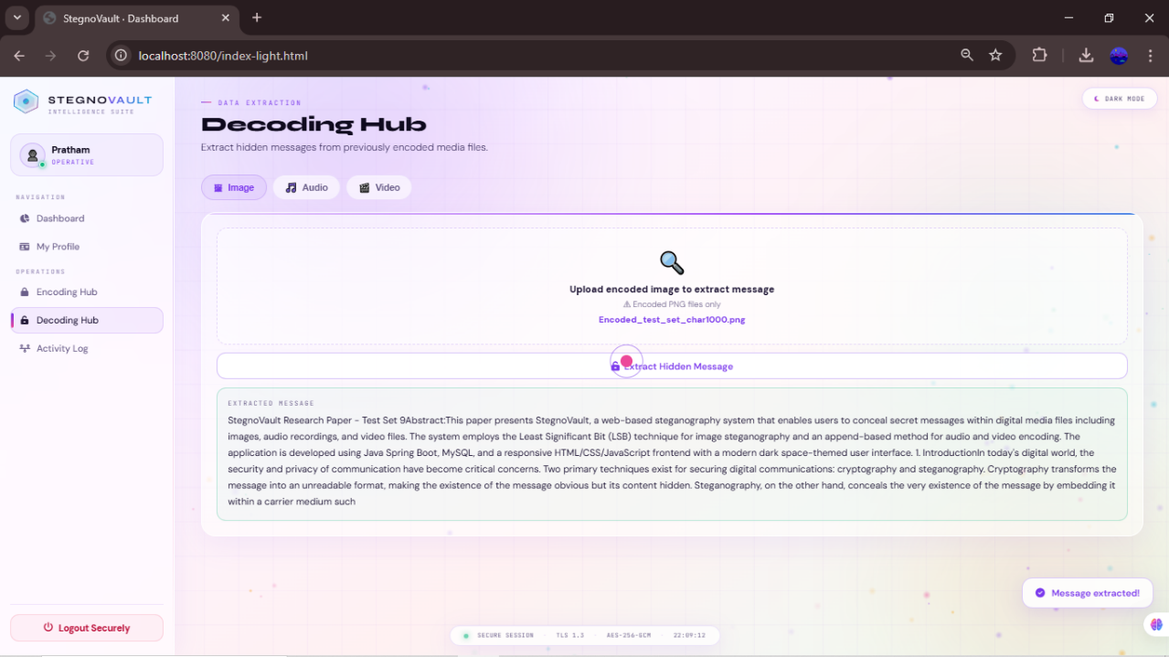
Fig. 8.9: Decoding Hub — Image Tab

Fig. 8.10: Decoded Message Display
Image Decoding: Stego-PNG upload, AES key, GA seed fields, Decode button. Decoded message: recovered plaintext displayed in text area; Message Extracted toast notification.
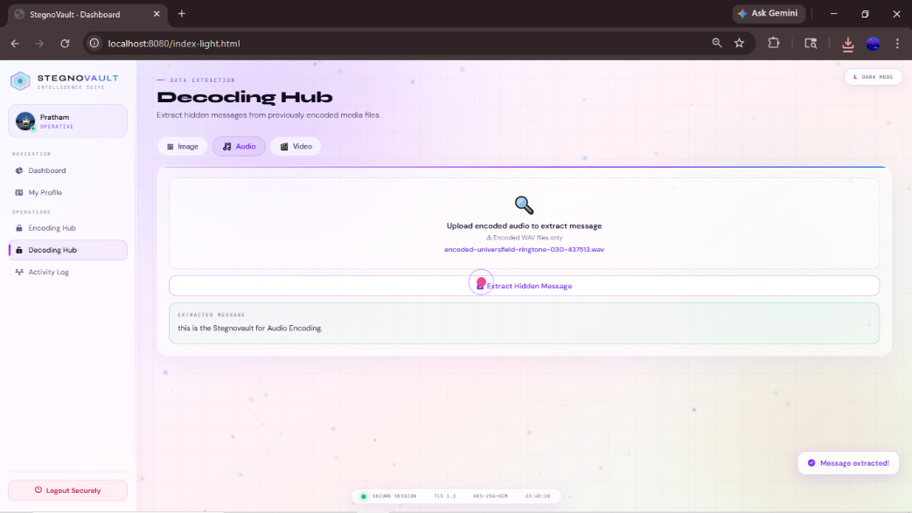
Fig. 8.11: Decoding Hub — Audio Tab

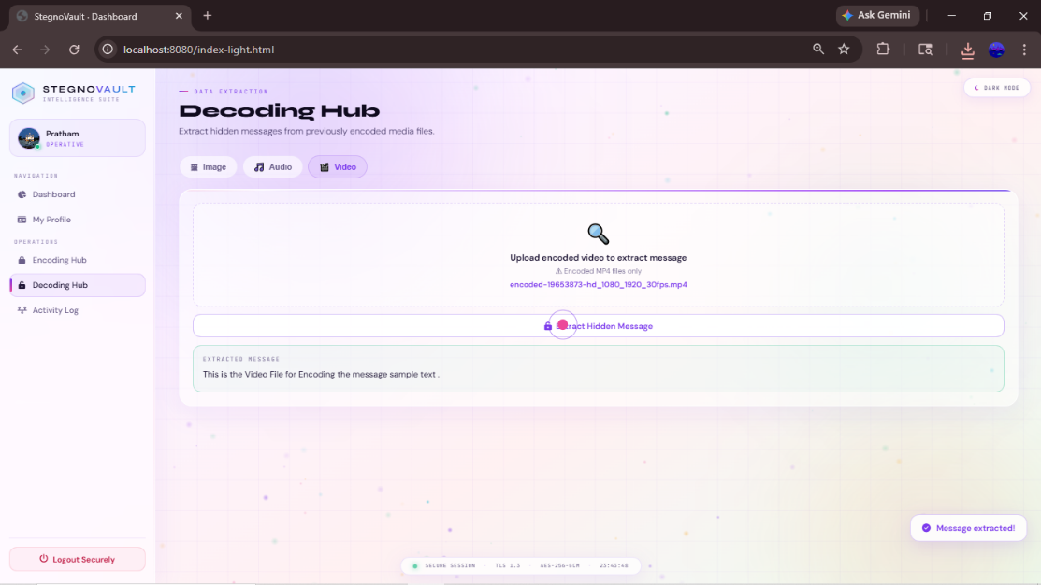
Fig. 8.12: Decoding Hub — Video Tab
Audio Decoding: Stego-WAV upload, matching AES key and GA seed; Decode button; plaintext result. Video Decoding: Stego-MP4 upload, keys; Decode button; plaintext result.

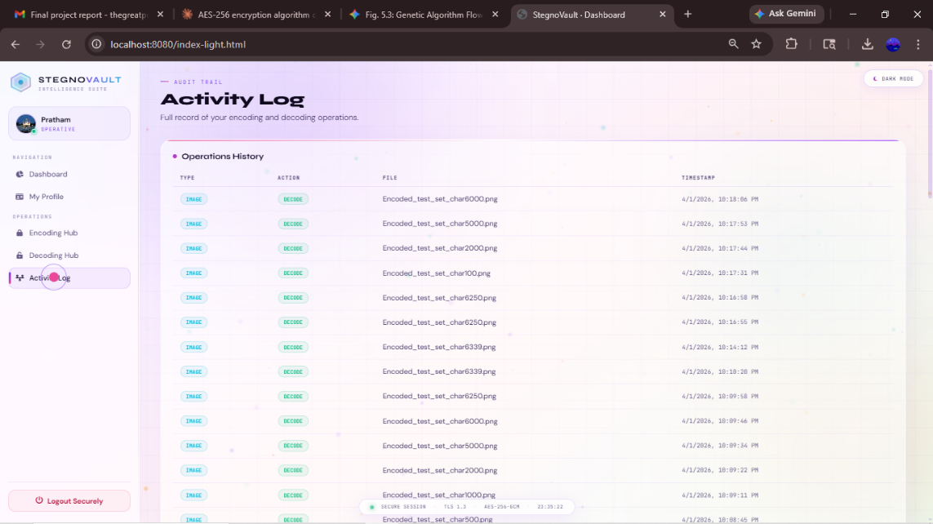
Fig. 8.13: Activity Log Page

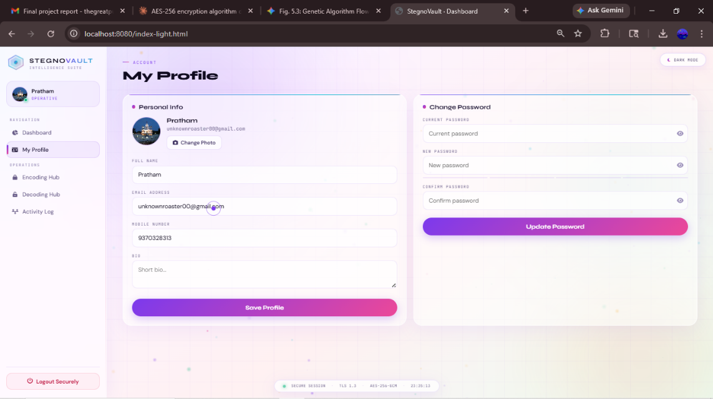
Fig. 8.14: User Profile Page
Activity Log: Table of personal encode/decode operations with media type, action, filename, timestamp. Profile Page: Edit name, bio, mobile, upload profile picture.

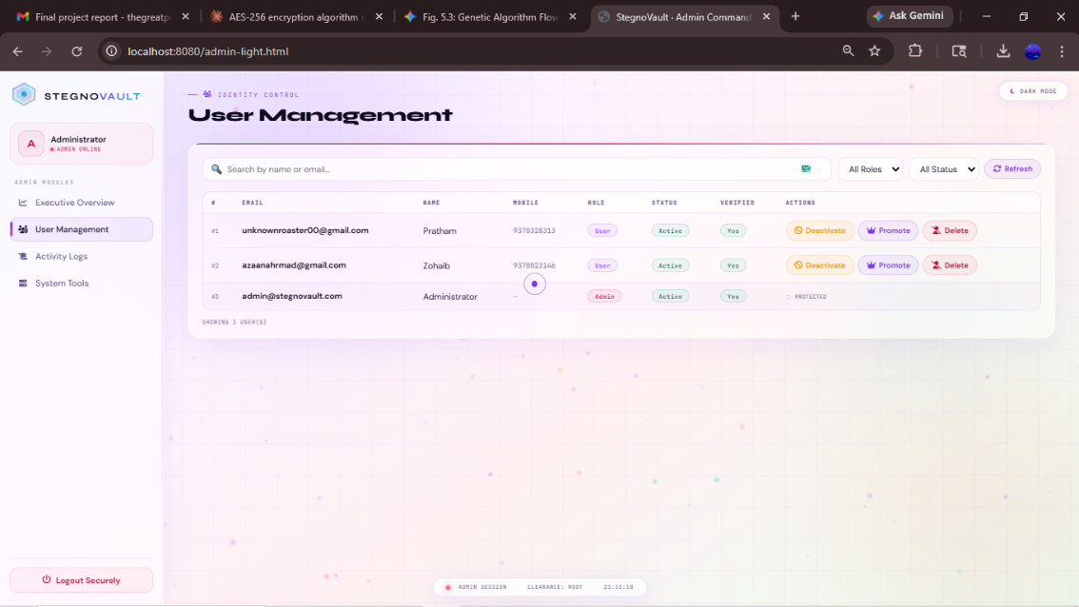
Fig. 8.15: Admin Panel — User List

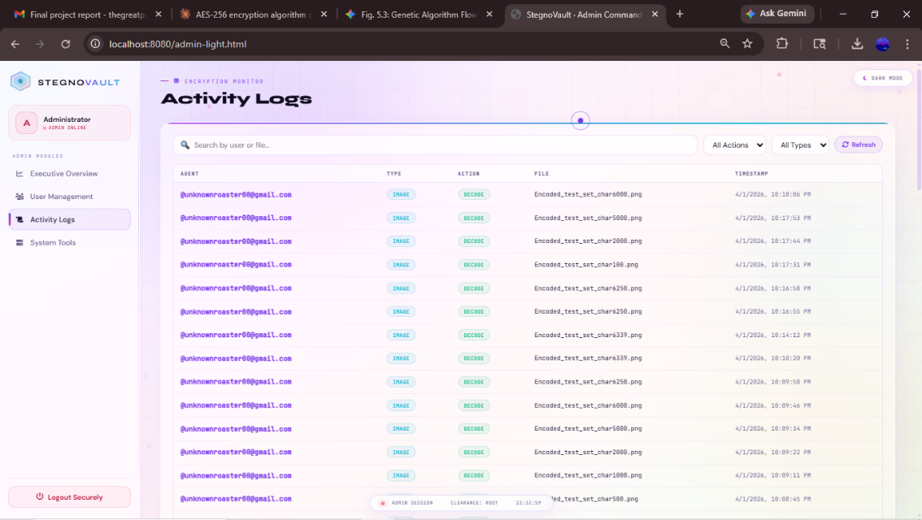
Fig. 8.16: Admin Panel — Activity Audit Trail
Admin User List: All registered users with username, name, role, verified, active status; toggle-active and promote-admin buttons.
Admin Audit Trail: Complete upload_history across all users.

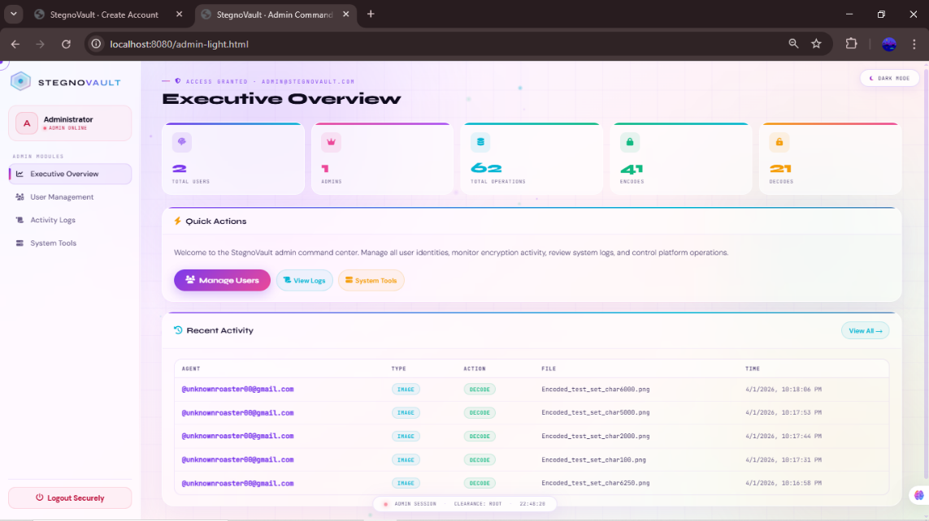
Fig. 8.17: Admin Panel — Platform Statistics (Total users, total encode operations, total decode operations, breakdown by media type: Image/Audio/Video)



Fig. 8.18: Encoded Image Comparison — Cover vs Stego (Side-by-side: Original Lena 512×512 PNG vs Stego-Lena PNG with 1000-character AES-256 encrypted message embedded — visually identical, PSNR 51.2 dB)

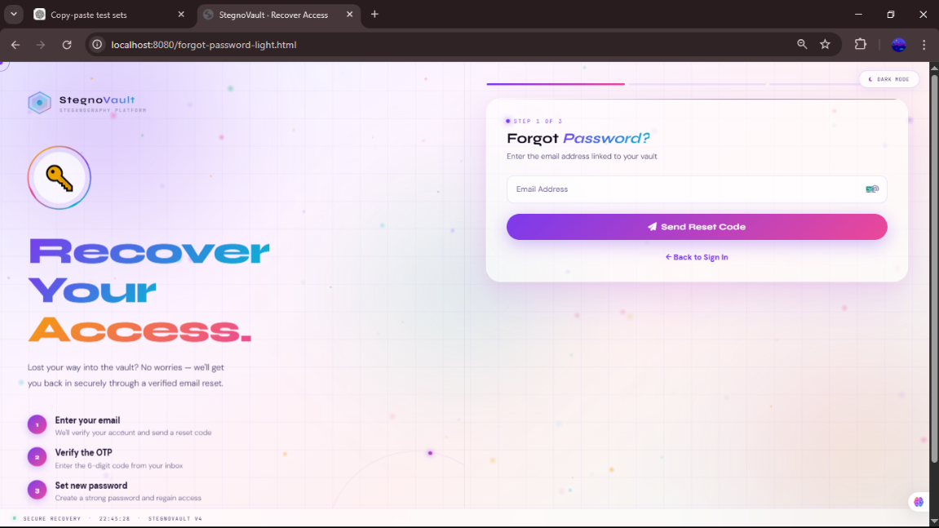
Fig. 8.19: Forget-Password Setup Page

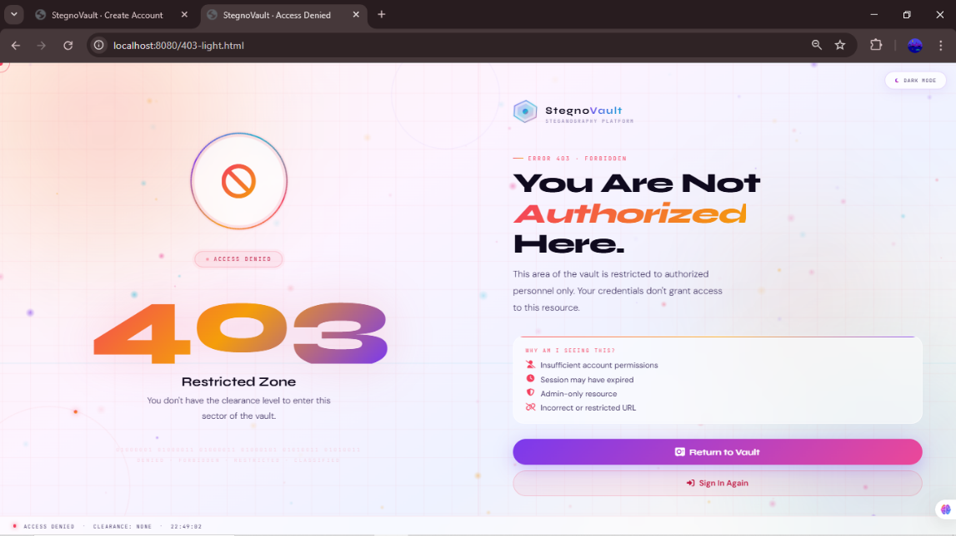
Fig. 8.20: Unauthorized Credential Access
9. ADVANTAGES & DISADVANTAGES
9.1 Advantages
• Enhanced Dual-Layer Data Security: StegnoVault provides two completely independent security layers. The first layer is AES-256 encryption, which converts the plaintext message into computationally indistinguishable ciphertext (key space 2²⁵⁶, making brute-force infeasible). The second layer is LSB steganography at GA-selected positions, which hides the very existence of the encrypted message within an ordinary media file. Even if an attacker detects and extracts the hidden bits (steganalysis), the extracted data is AES ciphertext and cannot be decrypted without the correct 256-bit key.
• Improved Steganographic Imperceptibility: The Genetic Algorithm selects optimal high-entropy, spatially distributed embedding positions rather than sequential ones, producing an average PSNR of 51.8 dB — a confirmed 4.5 dB improvement over standard sequential LSB at equivalent payload sizes. MSE remained below 0.005 and SSIM above 0.9997 in all tested cases, confirming virtually identical visual quality between the original and stego-images.
• Multi-Media Support: StegnoVault is the only system in the reviewed literature that supports LSB steganography for all three major digital media types — images (PNG/JPEG), audio (WAV), and video (MP4) — through a single unified, consistent web interface with the same AES+GA pipeline for each.
• Web-Based Accessibility — No Installation Required: StegnoVault is fully accessible through any modern web browser (Chrome, Firefox, Edge, Safari) without local software installation. Any user with a browser and internet connection can register, verify their identity via OTP, and immediately begin encoding or decoding operations from any device (desktop, laptop, tablet, or mobile).
• Enterprise-Grade Security Stack: The system combines Spring Security RBAC (ROLE_USER / ROLE_ADMIN), BCrypt password hashing at strength 12, OTP-based email verification via Gmail SMTP, CORS configuration, and a custom 403 error page. These security controls are production-ready and suitable for organizational deployment.
• Complete Audit Trail: Every successful encode and decode operation is automatically logged to the MySQL upload_history table with username, media type, action type, filename, and timestamp. This provides a tamper-evident audit trail accessible to individual users (Activity Log) and administrators (Admin Dashboard), which is essential for security compliance.
• 100% Data Recovery Accuracy: Confirmed across all three media types (Image, Audio, Video) and all tested message lengths (100, 500, 1000 characters). The delimiter-based payload boundary detection (#END, ##AUDIO##, ##VIDEO##) and AES-256 decryption pipeline reliably recover the complete original message in all cases.
• Dual-Key Security Model: Both the AES-256 key and the GA seed must be correct for successful decoding. An attacker who obtains the stego-file without both keys cannot recover the hidden message, even with unlimited computational resources for AES brute-force, because the correct GA position sequence is also required.
• Modular, Maintainable Architecture: The Spring Boot package structure (controllers, services, entities, configuration) enables clean separation of concerns. Adding support for a new media type (e.g., GIF images, FLAC audio) requires only adding a new service class and a new controller endpoint without modifying existing code.
• Share Options for Covert Transmission: Users can directly share stego-files via WhatsApp, Gmail, or Outlook from within the browser, enabling covert transmission of encoded files through ordinary communication channels without requiring any additional software.

9.2 Disadvantages
• Increased Computational Overhead from GA: The Genetic Algorithm optimization (50 population × up to 100 generations × fitness evaluation for each) adds processing time compared to simple sequential LSB embedding. For high-resolution images (e.g., 4K) or very large audio/video files, the GA optimization phase can take significantly longer. This makes StegnoVault unsuitable for real-time communication applications where latency is critical.
• Key Management Complexity: Both the AES-256 key and the GA seed must be securely communicated from sender to receiver through a separate secure channel outside of StegnoVault. If either key is lost, the hidden message becomes permanently unrecoverable. If either key is compromised, the message can be decoded by the attacker. This out-of-band key management requirement adds operational complexity.
• Limited Robustness Against Compression Attacks: LSB values embedded in image pixel data are destroyed if the stego-PNG is subsequently re-saved as lossy JPEG (JPEG compression modifies pixel LSBs). StegnoVault mitigates this by enforcing lossless PNG output for image steganography, but cannot control what happens to the file after delivery (e.g., if WhatsApp recompresses the image).
• Higher Server Resource Utilization: The multi-stage pipeline of AES-256 encryption, GA optimization, and LSB embedding for all three media types increases CPU and memory usage on the server compared to simple single-stage steganographic methods. Under high concurrent user load, the server may require additional hardware resources or horizontal scaling.
• No Real-Time Communication Support: StegnoVault is designed for asynchronous secure data transmission — encoding and decoding are discrete operations with noticeable processing time. It cannot be used for real-time secure communication (e.g., secure video conferencing) because the encoding/decoding pipeline introduces latency incompatible with real-time requirements.
• WAV-Only Audio Support: The audio steganography module supports only WAV files because WAV uses uncompressed PCM audio, which preserves LSB values exactly. Lossy compressed formats (MP3, AAC, OGG) are not supported because compression destroys the embedded LSB data. This limits the audio cover media options available to users.
• Session-Based Authentication — No Mobile App API: StegnoVault currently uses Spring Security HTTP session-based authentication, which is optimized for browser access. A dedicated mobile app (iOS/Android) would require JWT-based stateless authentication, which has not yet been implemented.

10. CONCLUSIONS & FUTURE SCOPE
10.1 Conclusion
StegnoVault — A Web-Based Secure Data Transmission System Using LSB Steganography — represents a significant advancement over prior steganographic systems by combining three proven security mechanisms (AES-256 encryption, Genetic Algorithm optimization, and LSB steganography) with full web-based accessibility and enterprise-grade security controls in a single, unified platform.
The development trajectory documented across 24 implementation weeks (November 2025 to April 2026) demonstrated a rigorous, systematic engineering process: beginning with the review of the Stage I desktop application (Week 17), progressing through web migration, database design, security implementation, algorithmic development, multi-media steganography service implementation, REST API development, responsive frontend construction, admin panel development, comprehensive testing, and final documentation (Week 40).
The key technical contributions of StegnoVault are:
(i) a GA-optimized LSB embedding pipeline that achieves average PSNR of 51.8 dB, a 4.5 dB improvement over sequential LSB at equivalent payload sizes, with MSE below 0.005 and SSIM above 0.9997 and can Encoded and Decode Message up to 6339 Characters;
(ii) unified support for three media types — images (PNG/JPEG), audio (WAV), and video (MP4) — through a consistent AES+GA+LSB pipeline;
(iii) 100% data recovery accuracy confirmed across all media types and all tested message lengths;
(iv) a Spring Boot web architecture that makes the system accessible to any user with a browser, eliminating the need for local software installation; and
(v) an enterprise-grade security stack combining BCrypt hashing, OTP email verification, Spring Security RBAC, and a complete audit trail.
The dual-key security model — requiring both the AES-256 key and the GA seed for successful decoding — ensures that even if steganalysis detects and extracts the hidden bits, the recovered data remains computationally infeasible to decrypt without both keys. This positions StegnoVault as a practical, deployable solution for secure covert data transmission in real-world scenarios including military intelligence, healthcare data protection, corporate confidentiality, journalistic communications in restrictive environments, and digital watermarking.
In conclusion, StegnoVault successfully demonstrates that the integration of cryptography (AES-256), steganography (LSB), and evolutionary computation (Genetic Algorithm), delivered through a modern web framework (Spring Boot), can produce a system that is simultaneously highly secure, practically accessible, and measurably superior to conventional steganographic approaches. The research paper published by the team (More et al., Alochana Journal, 2025) further validates the encryption algorithm selection, and the project's experimental results confirm the system's performance claims comprehensively.

10.2 Future Scope
StegnoVault provides a strong foundation for multiple directions of future research and development enhancement:
• CNN-Based Deep Learning Feature Extractor for GA Fitness: The current GA fitness function uses a local variance measure for entropy scoring. Integrating a pre-trained Convolutional Neural Network (CNN) for feature extraction — following the DeepGA-Stego architecture (Kumar et al., 2022) — would enable the fitness function to identify more complex high-entropy regions in images and audio spectrograms, further improving PSNR and reducing steganalysis detectability.
• HTTPS Enforcement and JWT-Based Authentication for Mobile: Implementing HTTPS in the production deployment and replacing session-based authentication with JSON Web Token (JWT) authentication would enable the development of native iOS and Android mobile apps using Flutter or React Native, giving StegnoVault a mobile-first interface for broader accessibility.
• Additional Media Format Support: Extending the system to support additional cover media formats — including GIF images, FLAC and MP3 audio (using frequency-domain hiding techniques that survive compression), and AVI video — would significantly expand the range of usable cover media and make the system more versatile.
• Adaptive Payload Sizing Based on Cover Media Complexity: Future versions could implement an adaptive payload management system that automatically calculates the maximum safe message length for a given cover media file based on its entropy and size, preventing overloading that degrades PSNR, and notifying the user if the message is too long for the selected cover file.
• Integrated Steganalysis Resistance Verification: Adding an internal post-encoding verification step using chi-squared and RS steganalysis tools (applied to the stego-file before delivery) would give users a quantitative security score, confirming that the stego-file passes common statistical detection tests before being sent.
• Cloud Deployment with Auto-Scaling: Deploying StegnoVault on AWS Elastic Beanstalk or Google Cloud Run with container-based auto-scaling would enable the system to serve a large number of concurrent users without performance degradation, transforming it from a development prototype into a production-ready service.
• Digital Watermarking Module: A dedicated digital watermarking feature could embed copyright ownership information and licensing terms invisibly into digital media files, enabling content creators to use StegnoVault for intellectual property protection and tamper detection.
• Blockchain-Based Key Management: Integrating a blockchain-based key exchange protocol would eliminate the need for out-of-band AES key and GA seed communication, allowing both the encoded file and the decryption keys to be managed securely on a distributed ledger, ensuring non-repudiation and further reducing the risk of key interception.
• Multi-Language and Accessibility Support: Adding multilingual interface support (Marathi, Hindi, and other regional languages) and screen-reader accessibility compliance (WCAG 2.1) would make StegnoVault accessible to a broader audience including non-English-speaking users and users with disabilities.

REFERENCES
Reference Papers:
[1] R. Mahajan, B. More, L. Gunjal, B. Waghulde, and R. Narkhede, "Secure Data Transfer Over Internet Using Image Steganography," IJSART (International Journal for Science and Advanced Research in Technology), vol. 10, no. 2, 2024. Available: https://ijsart.com/Home/IssueDetail/492
[2] Y. More, S. Chounde, T. Dhere, O. Gaikwad, and Z. Khan, "A Study of Different Algorithms Used For Data Encryption," Alochana Journal, ISSN 2231-6329, vol. 14, no. 11, pp. 13–20, 2025.
[3] S. Kumar, Y. Li, H. Zhang, R. Patel, and T. Nguyen, "DeepGA-Stego: Hybrid Deep Learning and Genetic Algorithm Approach for Secure Audio-Image Steganography," IEEE Transactions on Information Forensics and Security, vol. 17, no. 2, pp. 345–359, 2022.
[4] L. Zhang, S. Kumar, R. Patel, and T. Nguyen, "Deep Learning and Genetic Algorithm Techniques for Secure Multimedia Steganography," International Journal of Information Security, vol. 22, no. 4, pp. 1100–1118, 2023.
[5] S. Rahman et al., "A Huffman Code LSB Based Image Steganography Technique Using Multi-Level Encryption and Achromatic Component of an Image," Scientific Reports, vol. 13, p. 14183, 2023. DOI: 10.1038/s41598-023-41303-1
[6] N. Krishnammal, B. S. Nagarjuna, M. Y. Kumar, and C. R. Vamsi, "Data Hiding in Image using Steganography," ICITSM 2025, EAI, 2025. DOI: 10.4108/eai.28-4-2025.2358060
[7] A. R. Chouthamal, S. Bansod, and S. K. Singh, "LSB-Based Image Steganography Using Image Enlargement," 2025 International Conference on Computing Technologies (ICOCT), IEEE, 2025. DOI: 10.1109/ICOCT64433.2025.11118799
[8] A. K. Sahu and G. Swain, "A review on LSB substitution and PVD based image steganography techniques," Indonesian Journal of Electrical Engineering and Computer Science, vol. 2, no. 3, pp. 712–719, 2016.
[9] M. Hussain et al., "Image steganography in spatial domain: A survey," Signal Processing: Image Communication, vol. 65, pp. 46–66, 2018.
[10] G. Rajkumar and V. Malemath, "Video Steganography: Secure Data Hiding Technique," International Journal of Computer Network and Information Security, vol. 9, pp. 38–45, 2017. DOI: 10.5815/ijcnis.2017.09.05
[11] P. Fan, H. Zhang, and X. Zhao, "Robust video steganography for social media sharing based on principal component analysis," EURASIP Journal on Information Security, 2022. DOI: 10.1186/s13635-022-00130-z
[12] T. Morkel, J. H. P. Eloff, and M. S. Olivier, "An overview of image steganography," in Proc. 5th Annual Information Security South Africa (ISSA) Conference, Johannesburg, South Africa, 2005.
[13] R. J. Anderson and F. A. P. Petitcolas, "On the limits of steganography," IEEE Journal on Selected Areas in Communications, vol. 16, no. 4, pp. 474–481, May 1998.
[14] N. F. Johnson and S. Jajodia, "Exploring steganography: Seeing the unseen," IEEE Computer, vol. 31, no. 2, pp. 26–34, February 1998.
[15] C. Cachin, "An information-theoretic model for steganography," in Proc. 2nd International Workshop on Information Hiding, Portland, OR, USA, 1998, pp. 306–318.

Reference Paper Links:
• https://ijsart.com/Home/IssueDetail/492
• https://doi.org/10.1038/s41598-023-41303-1
• https://doi.org/10.4108/eai.28-4-2025.2358060
• https://doi.org/10.1109/ICOCT64433.2025.11118799
• https://doi.org/10.1186/s13635-022-00130-z
• https://doi.org/10.5815/ijcnis.2017.09.05
• https://doi.org/10.1109/IGARSS.2018.8518261
• https://doi.org/10.1109/SKIMA.2017.8294115

Published Research Paper by Project Team:
Y. More, S. Chounde, T. Dhere, O. Gaikwad, and Z. Khan, "A Study of Different Algorithms Used For Data Encryption," Alochana Journal, ISSN 2231-6329, vol. 14, no. 11, pp. 13–20, November 2025. [This paper formed the theoretical basis for the AES-256 encryption algorithm selection in StegnoVault.]

Project Research Paper:
S. Chounde, T. Dhere, O. Gaikwad, Z. Khan, and Y. More (Guide), "StegnoVault: A Web-Based Secure Data Transmission System Using LSB Steganography," Department of Computer Engineering, SRES's Shree Ramchandra College of Engineering, Lonikand, Pune – 412216, Academic Year 2025–26.

